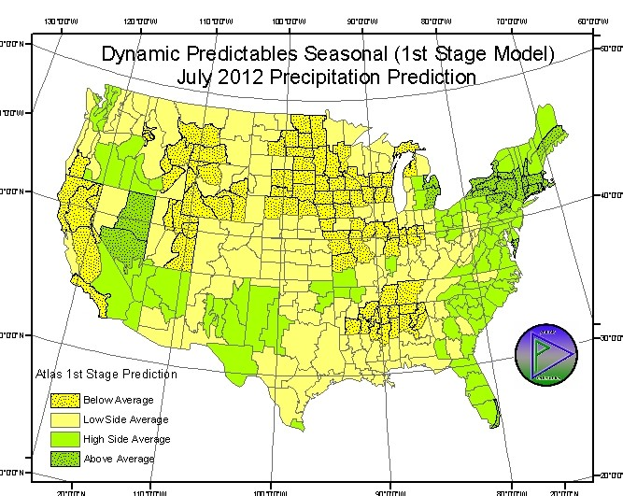
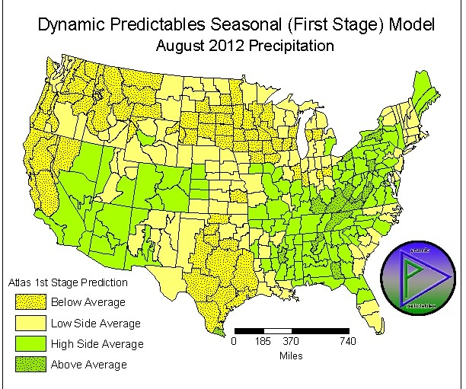
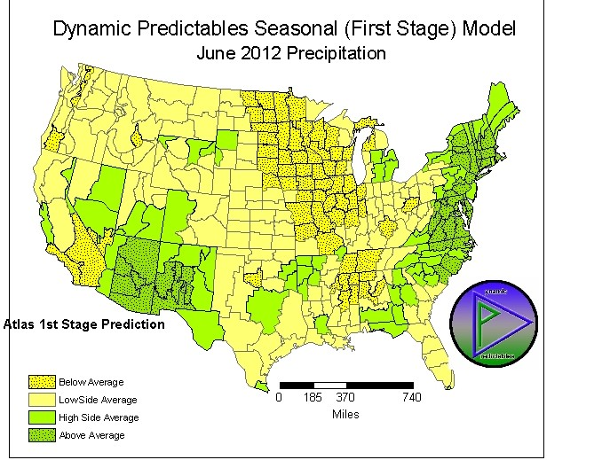

NCDC-CIRS FINAL OBSERVED MONTHS 6,7 PRELIMINARY 8. Predictions Above
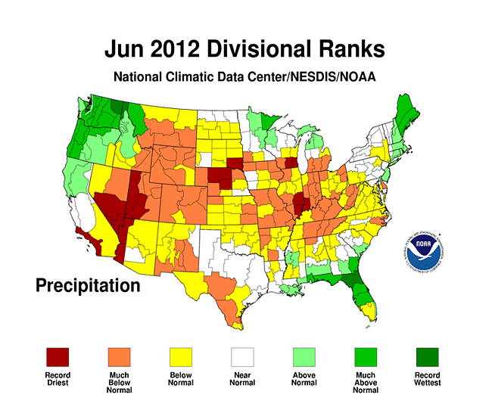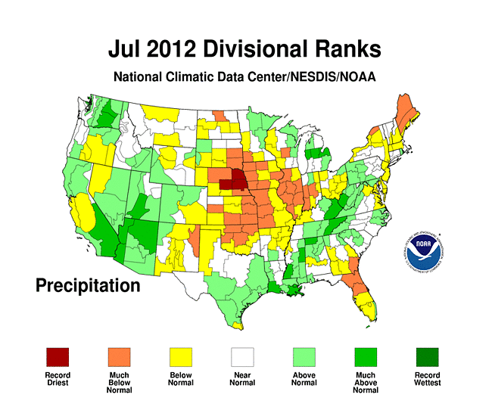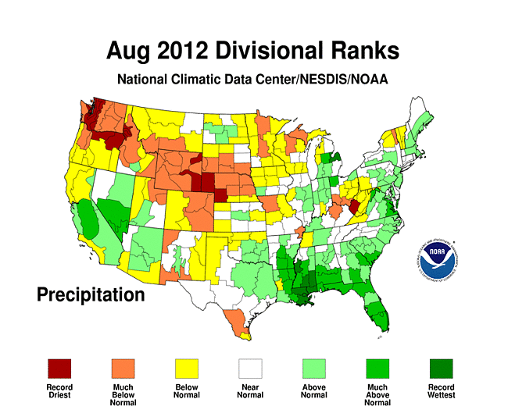

Production Potential 2012 (INITIAL PUBLIC RELEASE 20120601)

Much is being discussed about US crop production in 2012. The year started modestly dry and exceptionally warm with growers able to work the fields and plant the crop at an amazing pace. That pace was supported by a short winter and with modest soil moisture reserves.

Soil moisture is best in moderation. That said, the Palmer Drought Index (a measure of moisture below the surface) now shows significant dryness in soils from West Texas northward through Colorado and into Wyoming and westward through California. Only the Pacific Northwest is moist. And, the southeastern states, principally Georgia and Florida are severely dry. However, this year, much of the crop belt is dry enough for concern, and that includes Arkansas to western Indiana, much of Illinois and Iowa. The Crop Moisture Index, a measure of moisture at the surface, is non-committal, implying enough moisture to work with, but little reserve to sustain the crop should (if and when) some summer stress arrive.

The National Weather Service Climate Prediction Center offers some long range or near seasonal prediction, but this year’s precipitation outlook from CPC seems more uncertain than ever.

Dynamic Predictables offers a more comprehensive prediction, and this preview of summer moisture offers reason to pause and consider. This is not your typical year so drier than usual conditions from Illinois into Iowa and toward the Dakotas may not be as stressful as usual thanks to the early planting. But, extending the drier than usual conditions across the upper Midwest into July and through August should be a reason to push corn production to the downside. Beans, planted later, may be more subject to moisture reduction. August moisture across the eastern Belt may be too late to really help.

This is a quick overview, but much more detailed information is available. Visit http://www.dynamicpredictables.com

