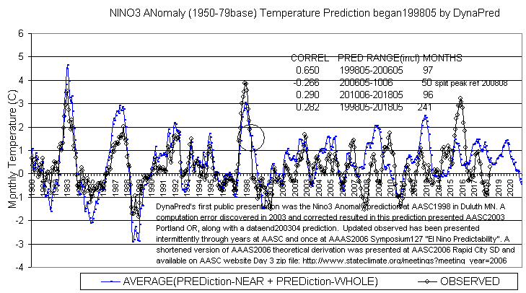
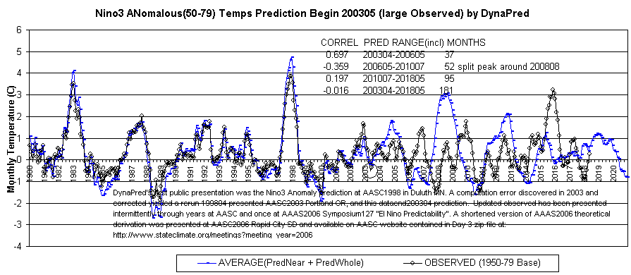
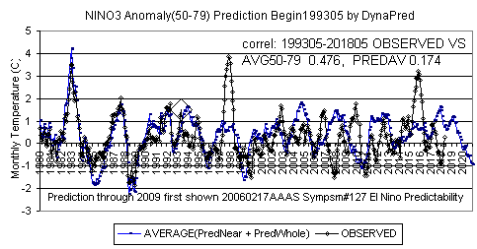
Shown above are Nino3 predictions with input data ending in April of 1998, 2003, and 1993. All were shown at AAAS2006 Symposium #127 “El Nino Predictability”. Input data ending with the big 1998 event has generally performed best. Note 1993 and 2003 predict a 2018-19 El Nino whereas 1998 predicts late 2019 peak.
Dynamic Predictables. Gregg Suhler.. http://www.dynapred.com t,o +1.573.815.0520 t,c,G 573.268.9845.
Handout at AASC2018 in Nebraska City, Nebraska

