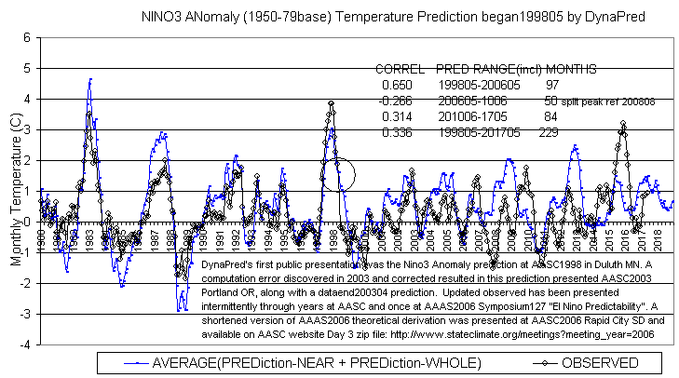
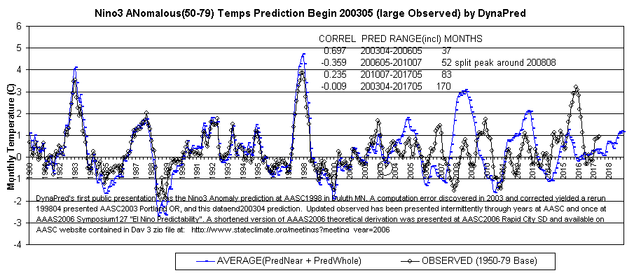
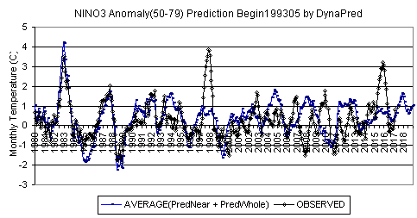
Note 199305 prediction first shown at AAAS2006 Symposium#127 “El Nino Predictability”.
Since early 2016, this 1993 prediction has been more accurate than from 1998 and 2003.
Dynamic Predictables LLC. Gregg Suhler. http://www.dynapred.com t,o +1.573.815.0520
T,c,Gregg 573-268-9845.
Handout at AASC2017 in Asheville, NC.

